Tessellations: Nancy Springer

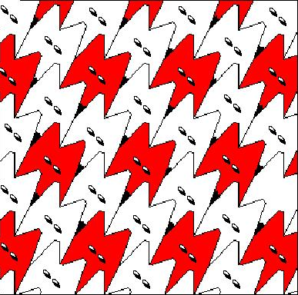
I used http://www.shodor.org/interactivate/activities/Tessellate/ to create the initial tile and tessellate the shape. The first thing that I saw was a fox. Next I screen captured the image and pasted it into Paint where I added the features to make it look more like a fox face. I filled in each individual nose, but got smarter as I went along and cut and paste the eyes. I had made the eyes in a white fox, so I ended up having to fill in red on some of them. I couldn’t decide if I wanted to just make the red ones a full face or all of them. It was fun to learn more about patterns and how they fit together. I didn’t realize there were so many different ways to use tessellations! I can see this project as a very motivating one for kids.

